**A452 Java Script**

**William Wood**

**7474**

**For June 2017**

**Task 2:**

**My plan for completing task 2:**

I am going to start by reading through the task and planning how I am going to complete the task. I’m then going to make a success criteria and decide what my code needs to do. I’m then going to code the task, testing each phase as I complete them. When I have finished my code I’m going to evaluate it against the success criteria, correcting my code if it does not meet all of the criteria points. I’m then going to annotate every line of my code, explaining what each line of it does.

**Success criteria:**

In order for this task to be successful I should:

* Create an array with the items: Printer, Tablet, Router, Floppy Disk, Monitor.
* Create a paragraph and assign an ID to it
* Sort the array in alphabetical order
* Display how many items are in the array
* Make sure that the code works in all browsers

**A screenshot of my array:**



**A screenshot of the code:**

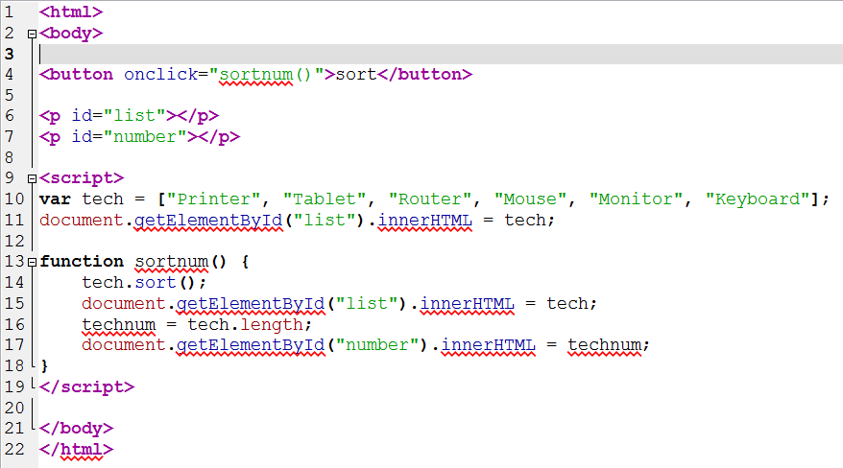

**Evidence of the code running:**

Initial run:

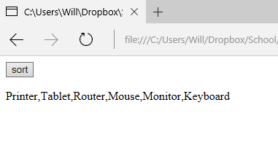

When the “sort” button is pressed, the array is sorted into alphabetical order and the number of items in the array is displayed:

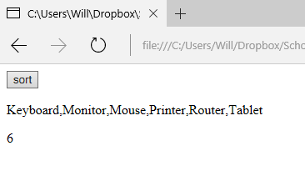

**Testing the code in different browsers:**

Initial run:

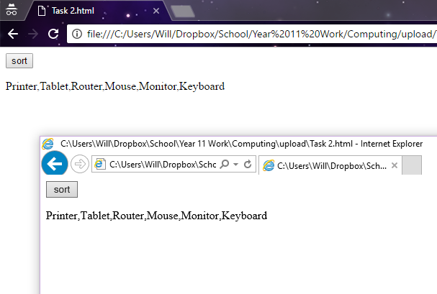

After the “sort” button is pressed:

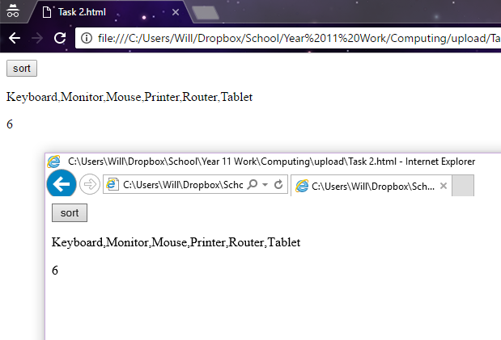

**Evidence of remedial action taken to correct errors in the code:**

My code ran without error in the initial run so no remedial action needed to be taken.

**Annotation of my code:**

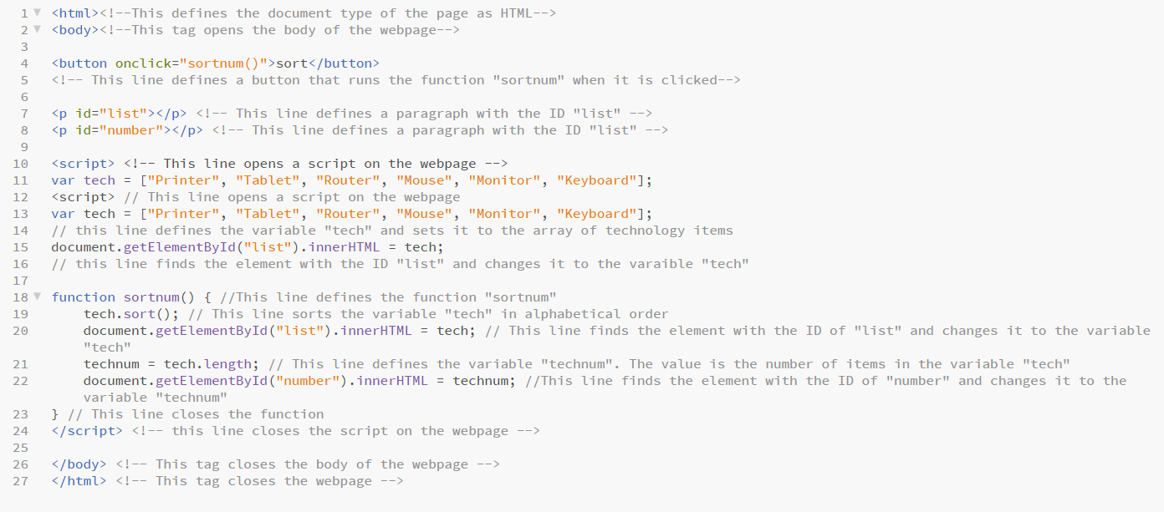

I annotated all of my HTML code using the comment tags **<!--** and **-->**. I also annotated all of my JavaScript code with “//”. This makes it easy for other people to see what each line of the code does in detail. This also helps with troubleshooting as you can clearly see what each tag does and how it works.

**Evaluation against success criteria:**

|  |  |  |
| --- | --- | --- |
| Criteria Point | How The Criteria Point Has Been Met | Evidence |
| Create an array with the items: Printer, Tablet, Router, Floppy Disk, Monitor. | I have created an array with all of the required items |  |
| Create a paragraph and assign an ID to it | I have created two paragraphs, both with different IDs |  |
| Sort the array in alphabetical order | I have created a JavaScript function that sorts the array into alphabetical order when a button is pressed |  |
| Display how many items are in the array | I have created a JavaScript function that displays the number of items in the array when the button is pressed. |  |
| Make sure that the code works in all browsers | I have tested my code in two different web browsers; Google Chrome and Internet Explorer |  |